SWINBURNE UNIVERSITY OF TECHNOLOGY
COS30043 – Interface Design and Development
OpenTexila – Student Management System
Group Project Report (Frontend and Interface Design)
Group G7
Aung Moe Thu (105292899) · Show Wai Yan (105293041) · Chia Kar You (106214483)
Live application: https://opentexila.site

1. Introduction
OpenTexila is a role-based student management web application built for COS30043. It joins course and class administration, enrolment, class sessions, attendance, announcements and student self-service in one interface for three user groups: administrators, lecturers and students. This unit is about interface design, so the report concentrates on the Vue.js frontend: the design system, navigation, page structure, forms, lists, feedback and responsive behaviour. Backend details appear only where they affect the interface.
The final production build is live at https://opentexila.site. Every screenshot was captured from that site on 14 November 2026 with the hosted demo accounts (1 admin, 8 lecturers and 50 students, 25 classes, 339 sessions and 30 announcements). The data is fictional, and the seeded lists run to two or three pages of 20 rows, so search, sort and pagination can be seen with realistic volumes. Three advanced features (the geofence and check-in settings, the drag-and-drop timetable and the attendance analytics) are each described in the individual reports, so this report covers the rest of the system.

2. Interface Design and Navigation
Design system. All pages share one set of design tokens: a red brand colour for primary actions, a navy sidebar, a neutral canvas, tinted success, warning and error colours, and a system font stack. Bootstrap 5.3 supplies the grid, forms, buttons and pagination, re-themed in one file, and a small set of reusable ot-* classes handles cards, notices and status badges. Red is the brand and action colour, blue is reserved for links and keyboard focus, and errors always carry a text message as well as colour.
Landing page. The landing page at “/” introduces the product to visitors (Figure 1). A dark hero section with a phone mock-up explains location-based check-in and offers a Log in button. Below it, a three-step “How it works” row, a “What each role can do” section with one card each for students, lecturers and admins, and a closing call to action make the system clear before sign-in. Because there is no public sign-up, the page tells visitors that an admin creates their account.
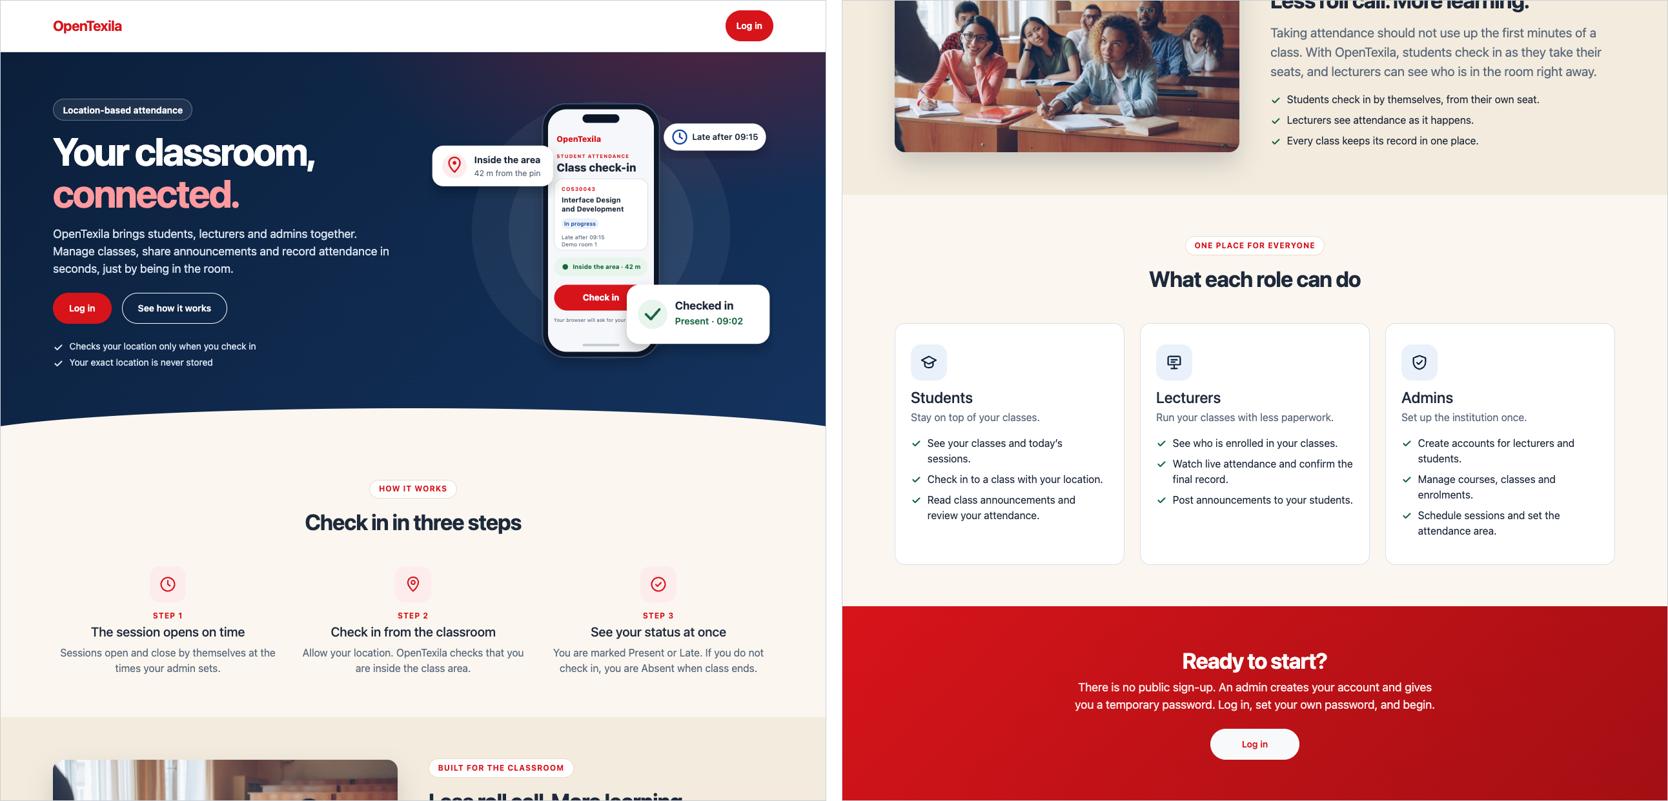
Figure 1. Landing page (full page, shown in two halves): hero, how it works, role cards and call to action.
Sign-in. Accounts are provisioned by an administrator, and the form says so. The form validates inline, announces each error beside its field and offers a Show button for the password (Figure 2). Signed-in users are redirected from public pages to the home page for their role.
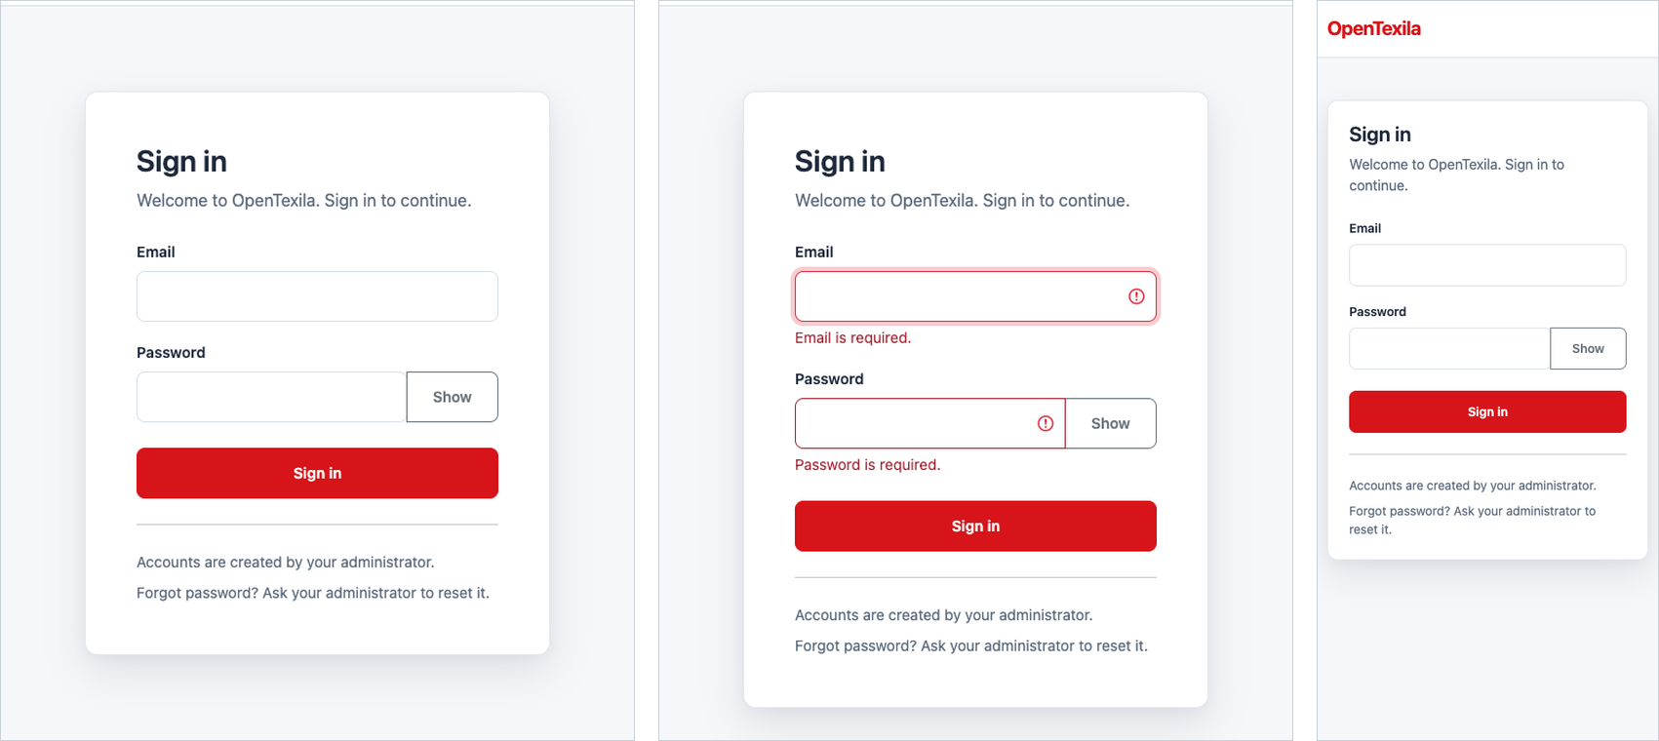
Figure 2. Sign-in page on desktop, with inline validation errors after an empty submit, and the same form on a 390 px phone.
Role-aware shell. After sign-in every page uses one layout: a collapsible navy sidebar, a top bar showing the user and role with Sign out, and a content area with a red eyebrow label, page title and short description. The sidebar lists only the destinations for the current role. Admins see Courses, Classes, Timetable, Enrolments, Announcements, Class attendance and Create account; lecturers see My classes, Announcements, Attendance and Analytics; students see My classes, Announcements and an expandable Attendance group. On phones the sidebar becomes an off-canvas drawer (Figure 3). Route guards also stop a user from opening another role’s pages by typing the address (Section 4).
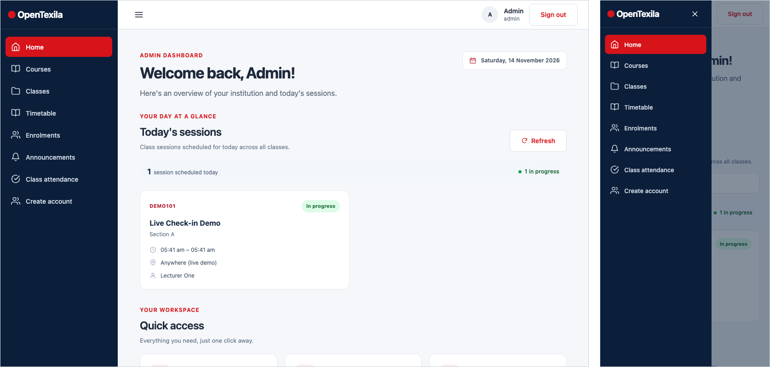
Figure 3. Admin home on desktop (left) and the collapsed mobile navigation drawer (right). The dashboard shows today’s sessions and quick-access cards with live counts.

3. Main Functionality by Role

3.1 Administrator
Courses and classes (full CRUD). Courses and classes are listed as cards with course and term filters, pagination and Edit, Students and Schedule buttons on each card. Create and edit forms group fields into sections, mark required fields, and show a summary banner (“Please correct the highlighted fields”) plus a message under each invalid field (Figures 4 and 5). A course or class is created and edited on a separate page, and the user is returned to the list with their filters kept.
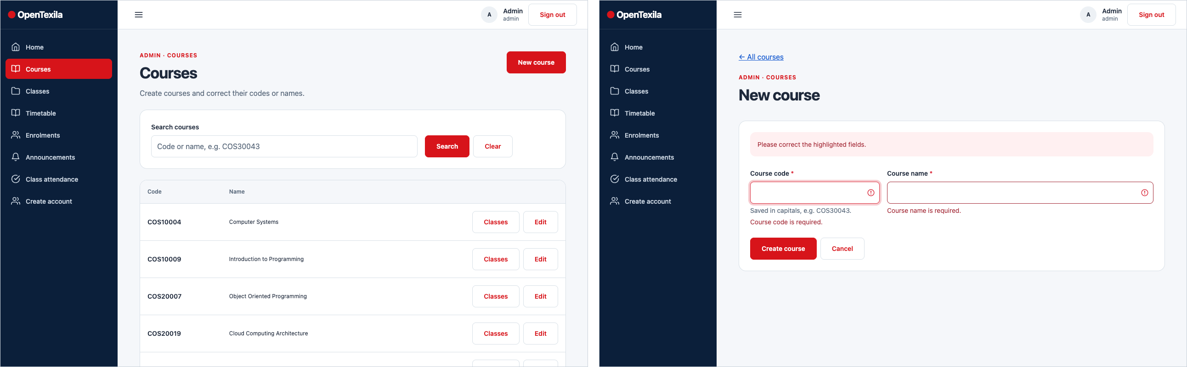
Figure 4. Admin Courses list (left) and the new-course form showing validation feedback (right).
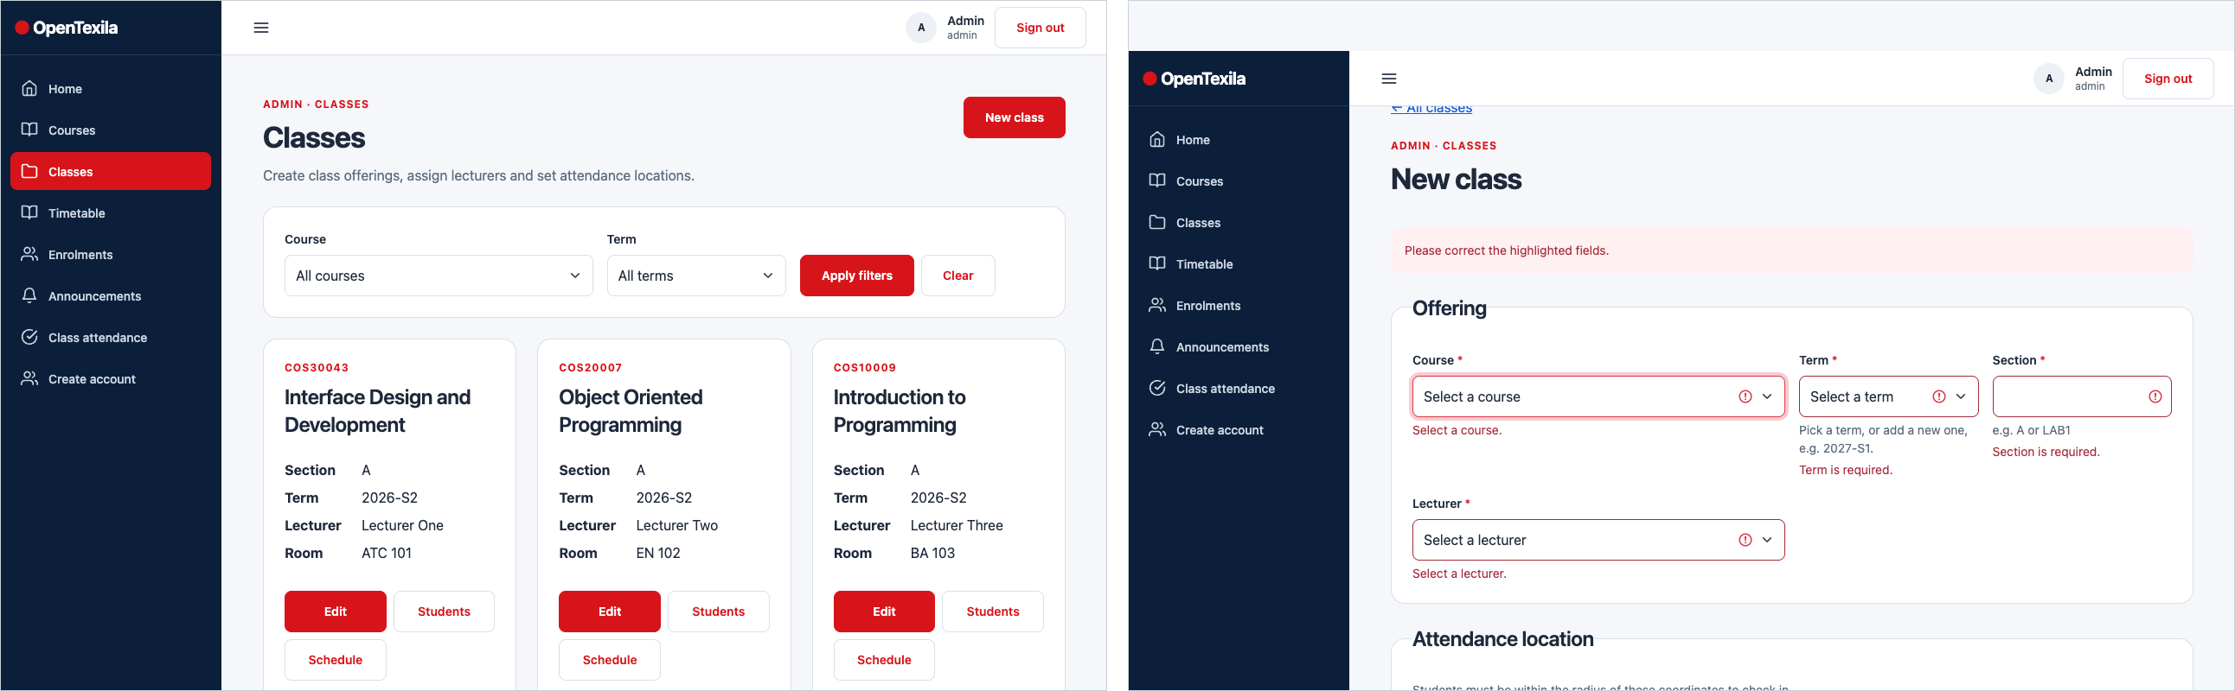
Figure 5. Admin Classes list with filters and per-class actions (left) and the new-class form with required-field errors (right).
Enrolments. The Enrolments page lists classes, and each class has a roster page where the admin adds and removes students, with duplicate enrolments blocked and the roster paginated for large classes (up to 28 students in the demo data) (Figure 6).
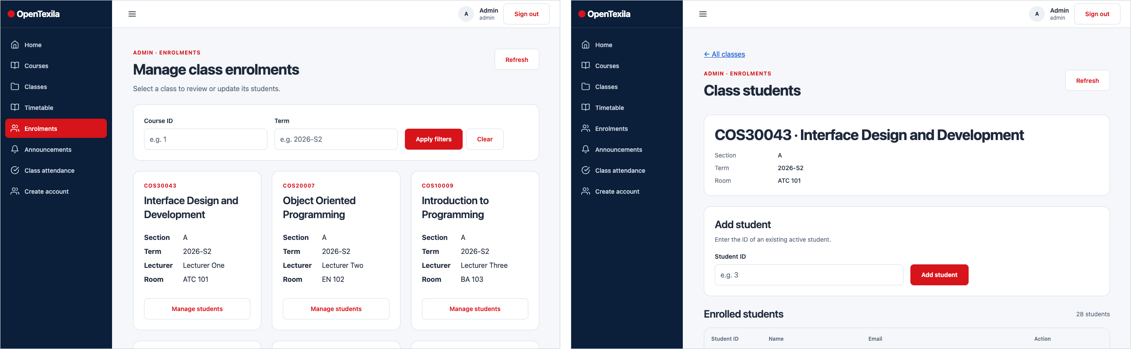
Figure 6. Enrolment management: class list (left) and a class roster page (right).
Class sessions and attendance records. Each class has a schedule page that lists its sessions with their attendance counts (for example Present 19, Late 7, Absent 2), a filter and a “Schedule a session” form for adding a session. A separate read-only Class attendance page lets the admin choose a class and review who attended (Figure 7).
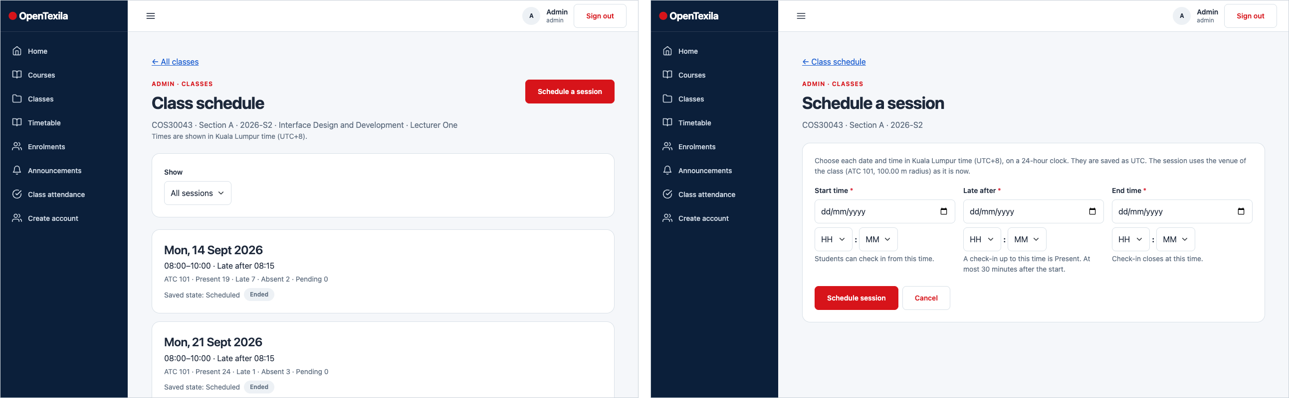
Figure 7. Class schedule with per-session attendance summary (left) and the session creation form (right).
Account creation and announcements. Create account lets the admin add a lecturer or student with a role, an email and a temporary password that can be shown or generated; the password must be at least 12 characters and the user must change it at first sign-in. Below the form a searchable, role-filtered Users list supports account management. The admin Announcements page shows posts from every class with the same search, class, category and sort controls that students and lecturers use (Figure 8).
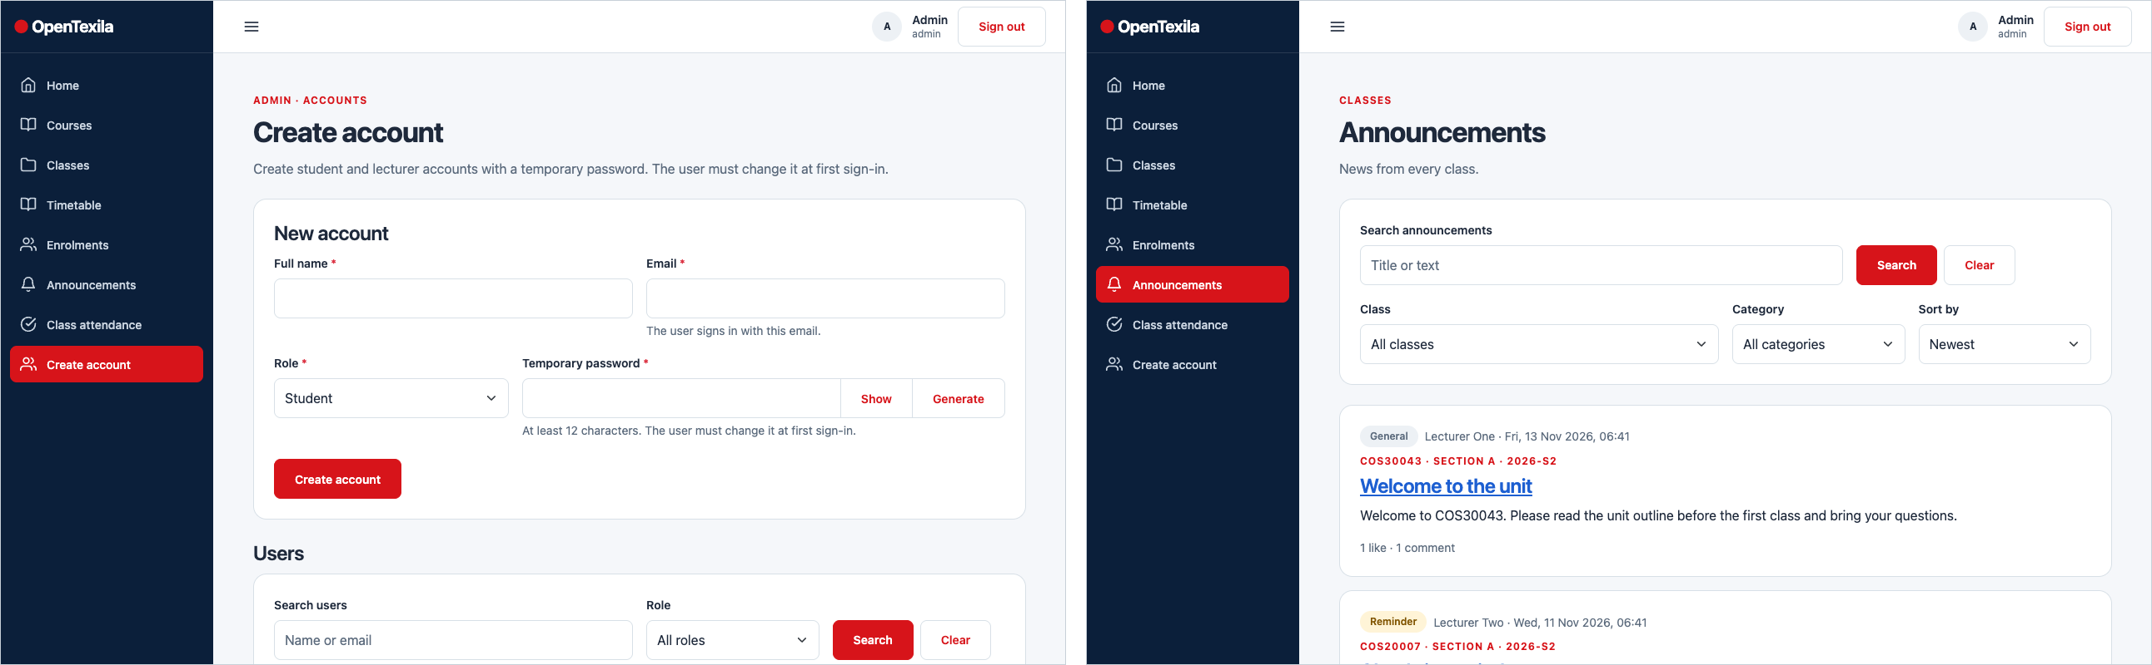
Figure 8. Create account form and searchable user list (left) and the admin view of all announcements (right).

3.2 Lecturer
Home and classes. The lecturer home page shows today’s sessions and quick-access cards. My classes lists the lecturer’s own classes, and each class links to a read-only student roster (Figure 9).
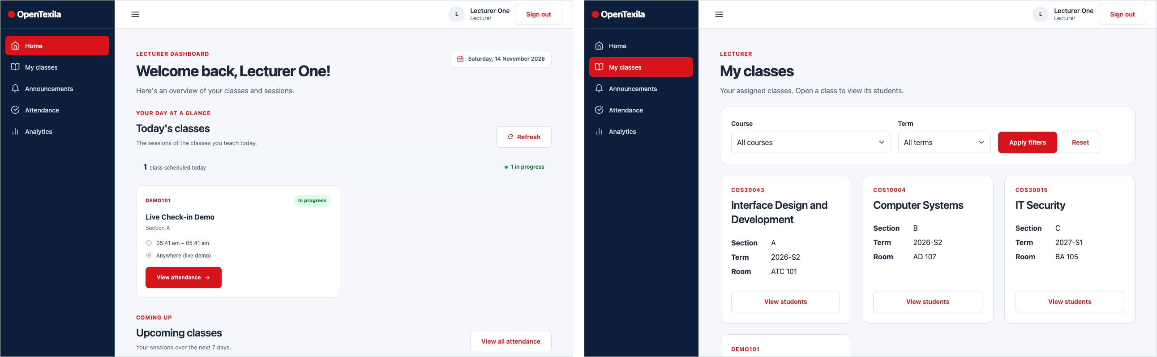
Figure 9. Lecturer home with today’s sessions (left) and My classes (right).
Attendance sessions and rosters. The Attendance page lists the lecturer’s class sessions with filters and pagination. A session page shows the class, room, time and late-after time, then a roster with one colour-and-text badge per student (Present, Late, Absent or Pending), the check-in time, a status filter and Previous / Next paging (“Page 1 of 2 · 28 students”) (Figures 10 and 11).
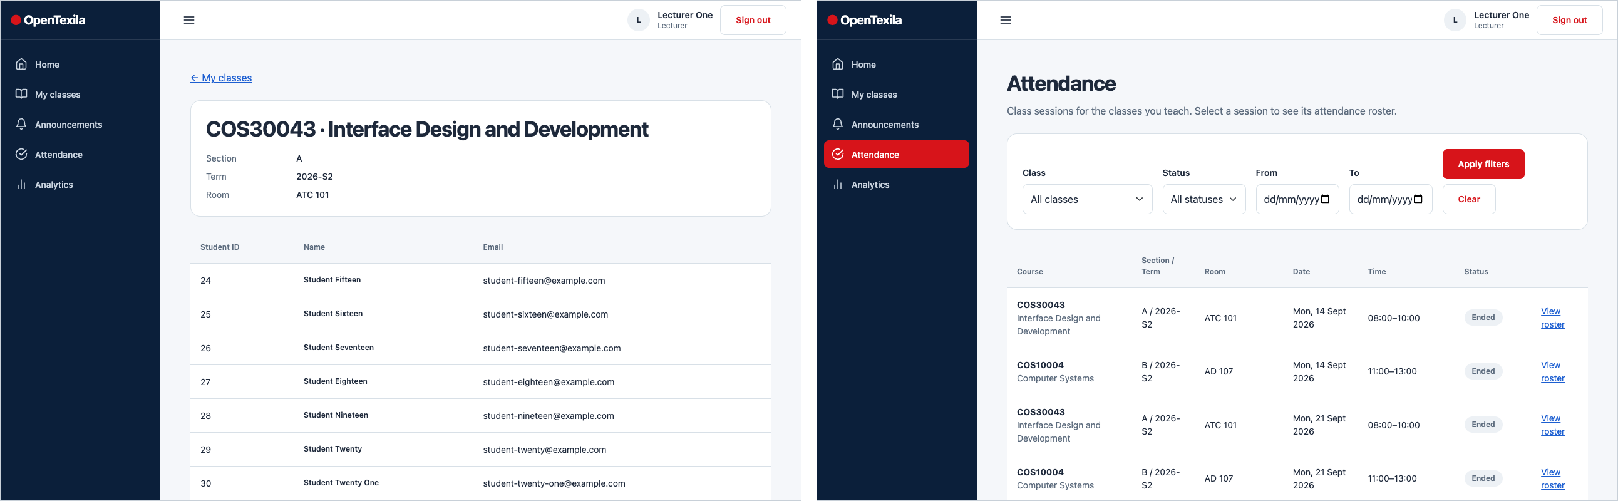
Figure 10. Lecturer student roster for a class (left) and the attendance session list (right).
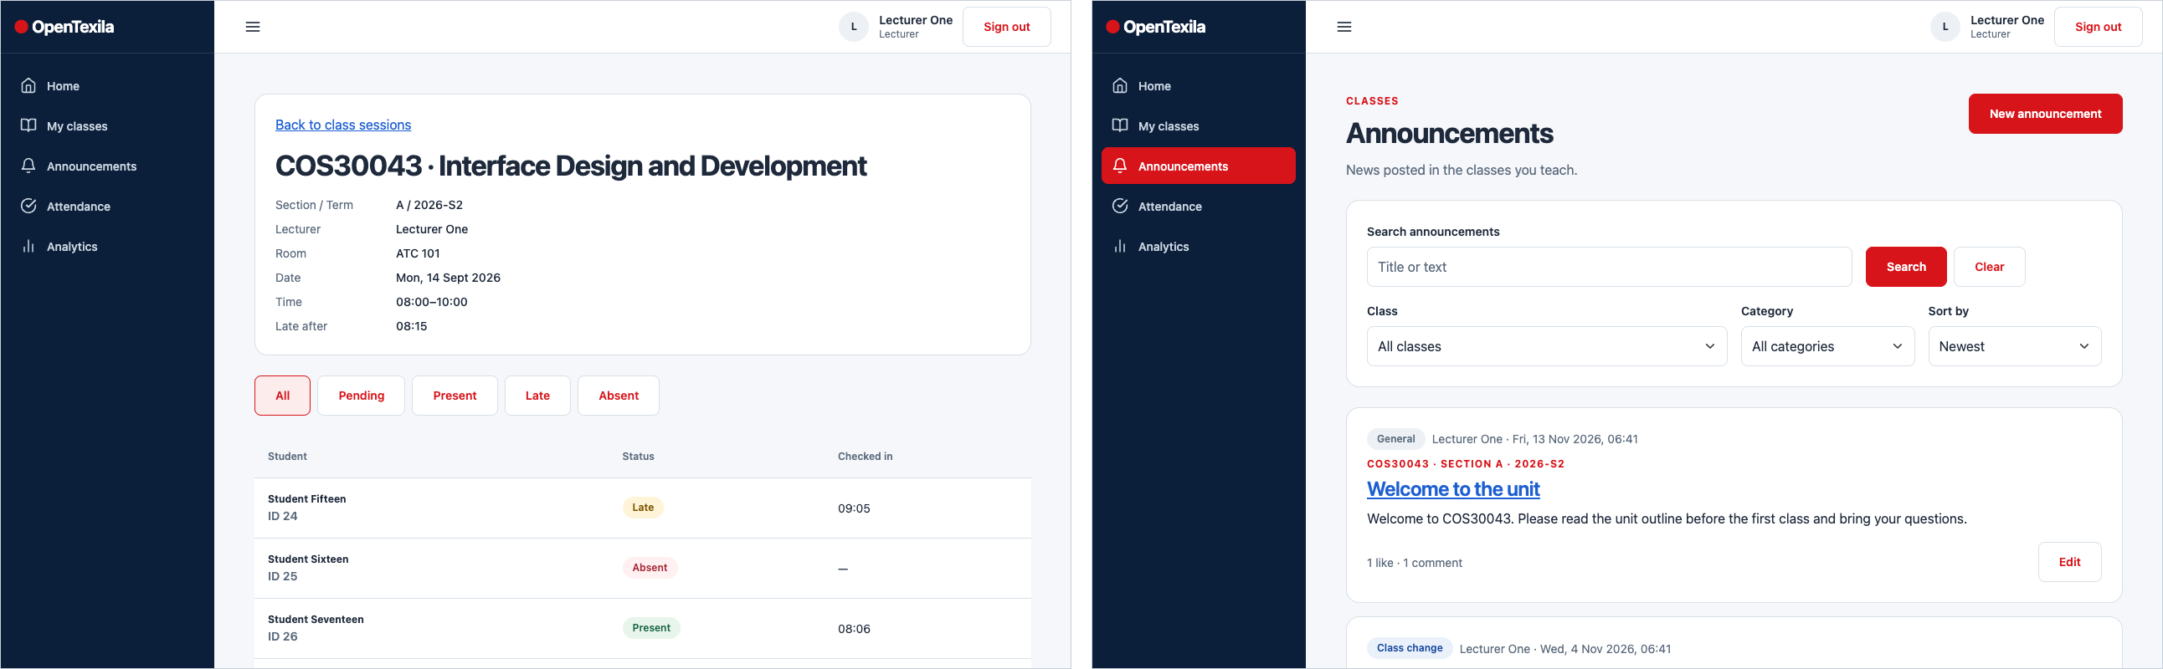
Figure 11. Session roster with status filter, badges and pagination (left) and the lecturer announcements list (right).
Announcements. Lecturers post news to one of their classes with a category (General, Exam, Reminder and others), a title of up to 150 characters and a body of up to 5,000 characters. The form shows live character counters and field-level errors. On an announcement page the lecturer can edit it and moderate by deleting comments (Figure 12). Deleting uses a confirmation dialog.
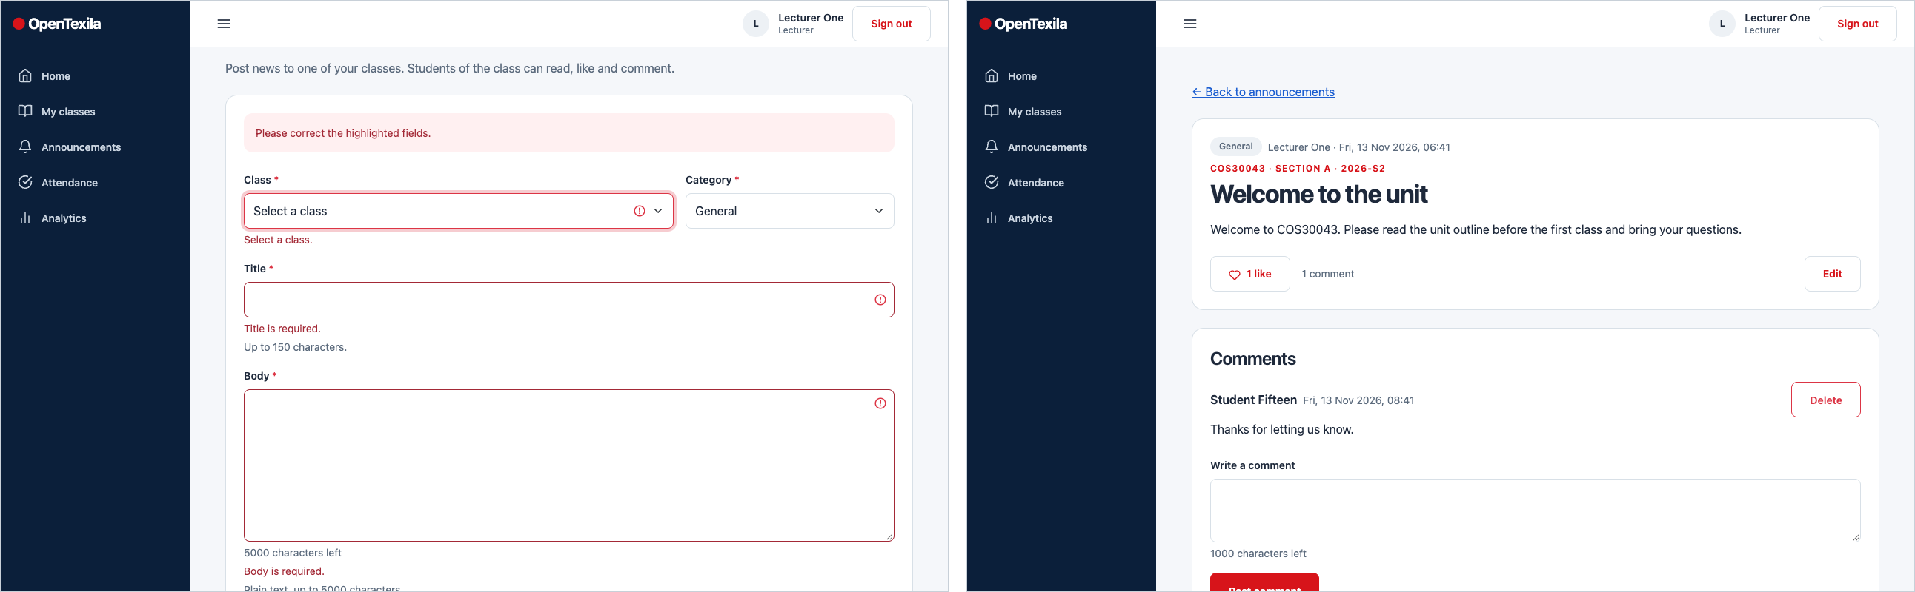
Figure 12. New announcement form with validation (left) and an announcement with an Edit button and comment moderation (right).

3.3 Student
Home, classes and scheduled sessions. The student home page highlights today’s classes with a “Go to check-in” button for any session in progress. My classes shows enrolled classes as cards, and Scheduled classes shows each session with its status (Ended, In progress) and the student’s attendance badge (Present, Late) (Figures 13 and 14). A session page lets the student check in with the browser’s location and shows the recorded result.
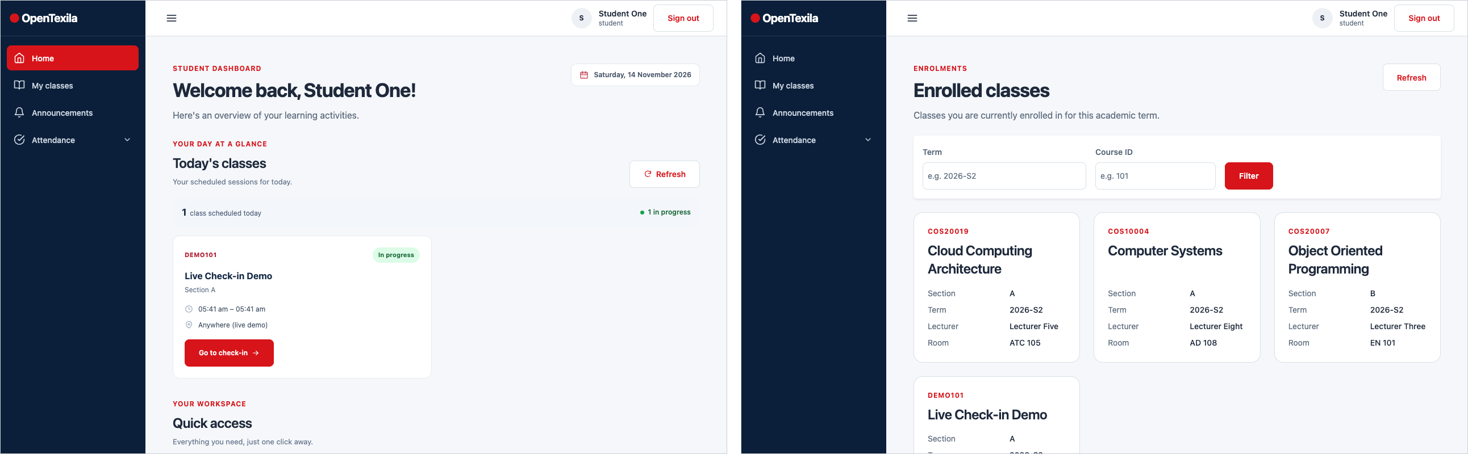
Figure 13. Student home (left) and My classes (right).
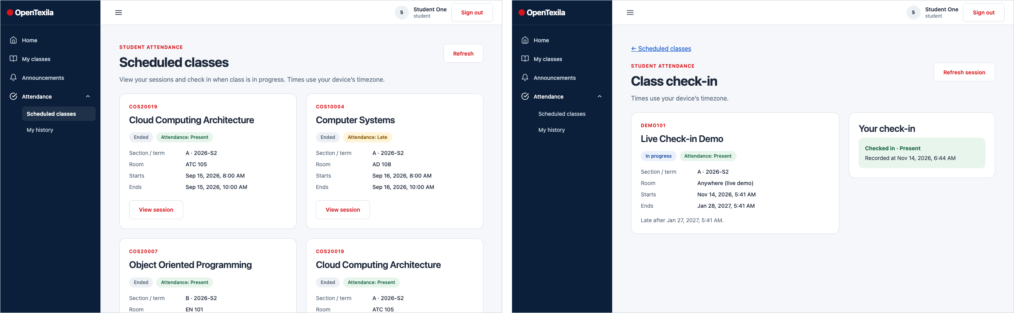
Figure 14. Scheduled classes with attendance badges (left) and the class check-in page with the recorded result (right).
Attendance history. My history lists past sessions with their status and uses pagination. On a phone the table becomes stacked rows (Figure 15).
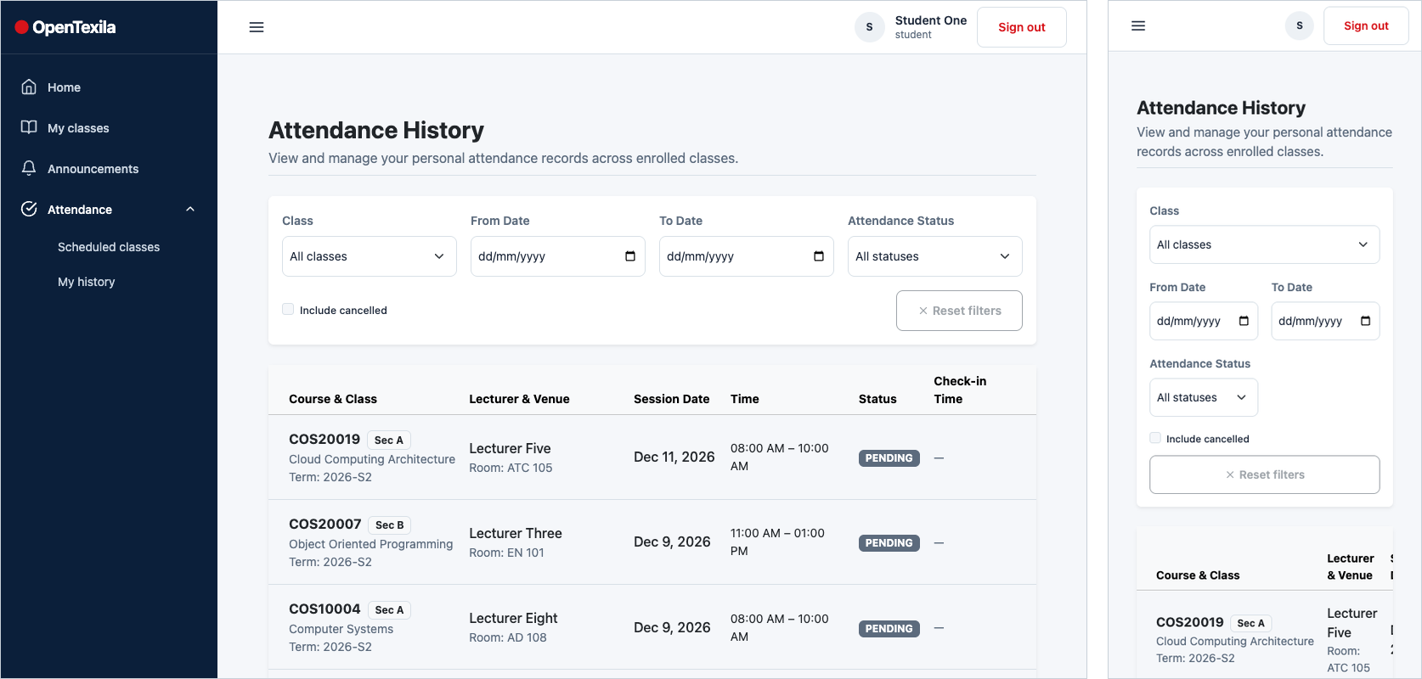
Figure 15. Attendance history on desktop (left) and phone (right).
Announcements and social interaction. Students search announcements by text and combine class, category and sort filters. On a post, a like button toggles between outline and filled red with a count, comments are written below with a 1,000-character counter, an empty comment shows “Write a comment first”, and students can delete their own comments (Figure 16).
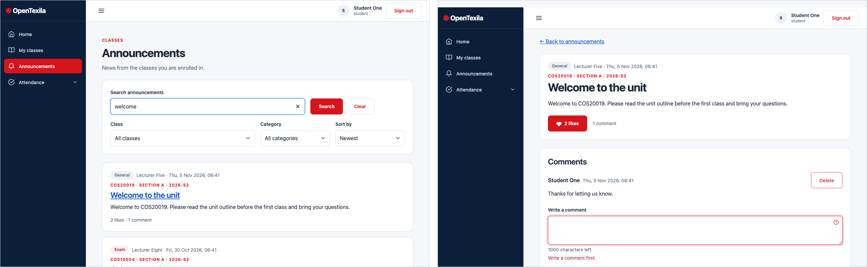
Figure 16. Announcement search (left) and a post with a liked state, comments and comment validation (right).

3.4 Responsive behaviour and error states
The layout is mobile-first and was checked at about 390 px (phone), 768 px (tablet) and 1280 px (desktop). Cards switch from three columns to two to one with the Bootstrap grid, the sidebar becomes a drawer, filter bars stack, and wide tables become stacked rows on phones (Figure 17). Unknown addresses show a “Page not found” page, and a user who opens a page for another role sees a plain access-denied message with a button back to their own pages. The seeded data shows list pages reflowing, and only the weekly timetable keeps horizontal scrolling.
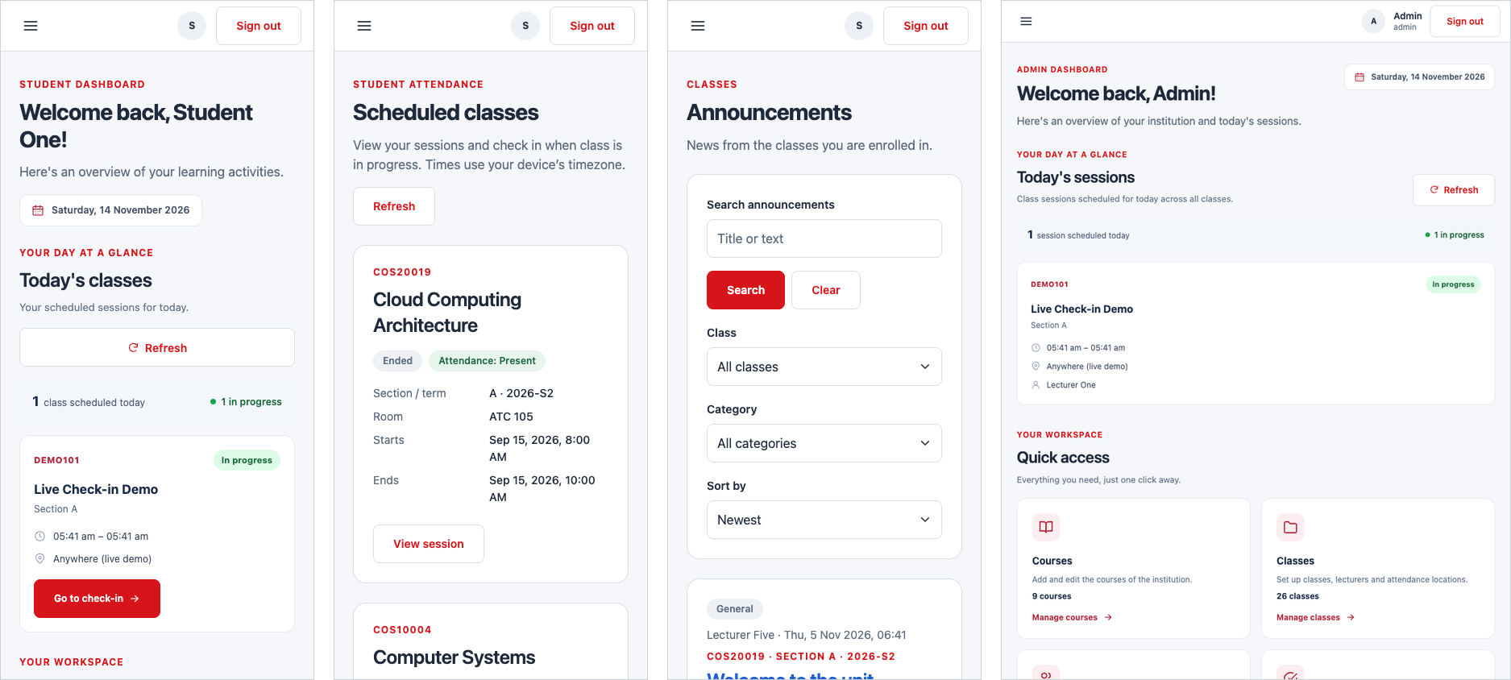
Figure 17. Student home, scheduled classes and announcements on a 390 px phone, and the admin home on a 768 px tablet (right).

4. Techniques Used (Frontend)
The table links each technical requirement to its implementation (88 single-file components written in JavaScript with <script setup>).
Requirement | Implementation in OpenTexila | Where to see it
Vue 3 + Vite; Bootstrap grid | Vue 3.5 and Vite 8; Bootstrap 5.3 loaded once, with col-* grid classes in cards, forms and dashboards, and a mobile-first layout. | Figures 5, 17
Component-based architecture | Feature folders (courses, enrolments, attendance, announcements, dashboard and others) with page components and small reusable parts (SessionList, RosterTable, LikeButton, FormField, pagination components). Shared pieces include the sidebar, icons, confirm dialog, notification host and a request-state component for loading, error and retry. | Source tree
Vue Router | About 40 routes, lazy-loaded with dynamic import() under a public layout and a protected layout. meta.requiresAuth, meta.guestOnly and meta.roles drive a global guard that redirects guests to sign-in, sends users to their role home, forces a first-time password change and shows an access-denied page. Redirect targets are sanitised. | Figures 2, 3
Directives, methods, computed | v-if / v-else for loading, empty and error states; v-for for cards, rows and options; v-model on filters and forms; v-bind and :class for status and active states; @click and @submit handlers. Computed properties and watchers derive filtered lists, page counts and form validity. | All figures
Search, sort, filter | Announcements: text search, class, category and sort. Classes: course and term. Attendance: status filter. Users: name or email and role. Class filters are kept in the URL query. | Figures 5, 8, 16
Pagination | Reusable pagination components (“Page 1 of 2 · 28 students”, Previous / Next) for class lists, rosters, sessions and history. | Figures 11, 15
Forms and validation | Required-field, format and range checks with inline messages, aria-invalid, a summary banner and character counters (title 150, body 5,000, comment 1,000). | Figures 2, 5, 12
Create, edit, delete content | Courses, classes, sessions, enrolments, accounts and announcements; delete actions use a confirmation dialog. | Figures 4–12
Social interaction | Like / unlike and comments on announcements, with an error and retry path if a request fails. | Figure 16
REST API integration | A shared api-client wraps fetch (cookie session, CSRF header, error mapping). Components show loading, error and “Try again” states instead of failing silently. | Source tree
Coding conventions | Consistent naming (PascalCase components, camelCase functions, feature folders), Prettier formatting (npm run format:check) and one shared set of design tokens and ot-* classes. | Source tree

5. Innovative Features
The project includes three advanced Vue features: a drag-and-drop timetable with undo, redo and conflict detection (vuedraggable); a Leaflet map-based geofence editor with a check-in simulator; and Chart.js attendance analytics with “View as table” alternatives. Each is explained in detail, with its rationale and techniques, in the individual report of the member who built it. Beyond those, the interface relies on several shared patterns that make the other features feel consistent: one reusable form-field component for labels, hints and errors; one request-state component for loading, empty and error views; a shared confirm dialog and notification host; and reusable filter and pagination components.

6. Usability and Accessibility Evaluation
We evaluated the production site against Nielsen’s usability heuristics and the main WCAG principles, using the three demo roles, keyboard navigation and three screen widths. Findings are manual observations, not automated test results.
Area | Strengths observed | Improvements to consider
Visibility of status and feedback | Status badges (Present, Late, Absent, Ended, In progress) always carry text; success, error and loading notices use consistent styles; failed requests offer “Try again”; empty states explain what to do next (“Choose a class above…”). | Make save confirmations more prominent and add a progress indicator for slower saves.
Consistency and standards | One layout, colour system and set of form and button patterns across all roles; back links such as “← All classes” behave predictably; the same search, class, category and sort controls appear for every role. | Several sidebar items share the same book icon (Courses, Timetable, My classes); give each destination a distinct icon.
Error prevention | Required fields are marked and checked before submit; duplicate enrolments are blocked; confirmation dialogs guard deletions; route guards block wrong-role pages. | Add undo for deletions; warn before leaving a long form with unsaved changes.
Recognition over recall | Filters keep their values; cards show section, term, room and lecturer; quick-access cards show counts. | Show the date as well as the time on sessions that span several days (the live-demo card reads “05:41 am – 05:41 am”); let the admin attendance page remember the last selected class.
Responsive design | Layout reflows at 390, 768 and 1280 px; the sidebar becomes a drawer; stacked rows replace wide tables. | Add a clearer cue for horizontally scrolling views.
Accessibility | Skip-to-content link; visible focus ring; labelled form fields with aria-invalid and role="alert" messages; descriptive aria-labels (for example “Edit COS30043 section A, 2026-S2”); reduced-motion styles; colour is never the only signal. | Run a screen-reader audit (NVDA, VoiceOver) and a contrast scan; make the Escape key close every dialog.

7. Conclusion
OpenTexila delivers a coherent, role-aware interface on a live deployment. A single design system keeps more than forty routes visually consistent, Vue components and Vue Router separate the three user journeys, and Bootstrap’s grid keeps pages usable from phone to desktop. Create, search, sort, paginate, validate and moderate patterns are reused across courses, classes, enrolments, accounts, attendance and announcements. The main improvements are small: clearer icons, fuller date display for multi-day sessions, stronger save confirmations and a formal accessibility audit.

